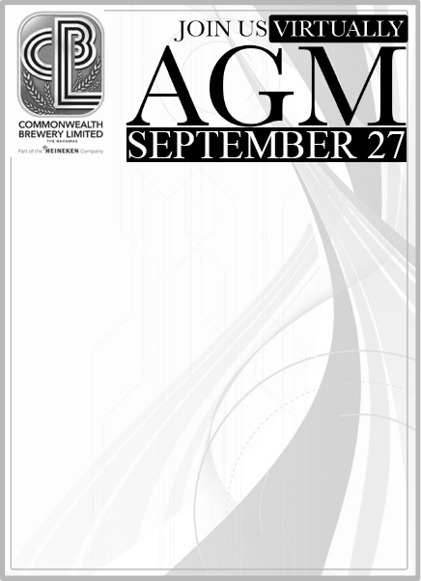

Due to Covid-19 regulations enforced in the Commonwealth of The Bahamas limiting the size of physical gatherings, the Annual General Meeting (AGM) of Commonwealth Brewery Limited will be held for our shareholders in a virtual meeting place on September 27, 2021 at 5:00pm, as advised in the Proxy Statement dated September 16, 2021.

**Register now to attend at:**

<https://www.cblbahamas.com/>

Click the link under 2021 Annual General Meeting. Kindly register in advance of the meeting to avoid delays in admittance to the virtual AGM.

You can obtain a copy of our 2020 Annual Report and resolution at the below link.

<https://www.cblbahamas.com/investors/page/reports.html>